LAB REPORT

COURSE: Mathematical Modelling And Simulation

SUBJECT CODE:MC-302

SUBMITTED BY: Lokesh Godara
ROLL NO. : 23/MC/082

Submitted To : Prof. Aditya Kaushik
& Mr. Asish Saini



DEPARTMENT OF APPLIED MATHEMATICS

DELHI TECHNOLOGICAL UNIVERSITY
(Formerly Delhi College Of Engineering)
Bawana Road, Delhi-110042

INDEX
S.No. | Experiment | Date | Signature
1. | Write a program to draw direction fields for the system of differential equations with constant coefficients.
2. | Write a program to find the steady-state solution, draw its phase plane plot for the system of ODEs and plot the solution of the system.
3. | Write a program to find critical points, Jacobian matrix, eigen values and eigen vectors of system of differential equations with constant coefficients.
4. | Develop a MATLAB function to check the stability of a linear system using the Routh-Hurwitz criterion.
5. | Write a program to check the stability of a linear system using the Lyapunov function.
6. | Simulate the Lotka-Volterra prey-predator model and analyze the population dynamics over time.
7. | Implement the SIR model for an epidemic and analyze how varying parameters (infection rate, recovery rate) affect the spread of disease.
8. | Simulate and analyze the saddle-node bifurcation in a simple dynamical system.
9. | Simulate a transcritical bifurcation in a simple system.
10. | Simulate the chaotic behavior of the Lorenz system.

Experiment 1
Aim: Write a program to draw direction fields for the system of differential equations with constant coefficients.
Theory: A system of linear differential equations with constant coefficients can be represented as:
$\frac{dx}{dt}$= ax + by
$\frac{dy}{dt}$ = cx + dy
A direction field (or slope field) is a graphical representation of the solutions to a first-order differential equation. It shows the slope of the trajectory at various points in the phase plane, indicating the direction a solution curve will take.
Code:-

% Define the grid of points for the phase plane

[x, y] = meshgrid(-5:0.5:5, -5:0.5:5);

% Define the system coefficients

a = 2; b = -1;

c = 1; d = 1;

% Calculate the derivatives at each point

dx = a*x + b*y;

dy = c*x + d*y;

% Normalize the vectors so the arrows have a uniform length (optional for better visualization)

L = sqrt(dx.^2 + dy.^2);

L(L==0) = 1; % Avoid division by zero

dx_u = dx ./ L;

dy_u = dy ./ L;

% Plot the direction field using quiver

figure;

quiver(x, y, dx_u, dy_u, 0.5, 'b');

title('Direction Field for the System of ODEs');

xlabel('x');

ylabel('y');

axis tight;

grid on;

Output:-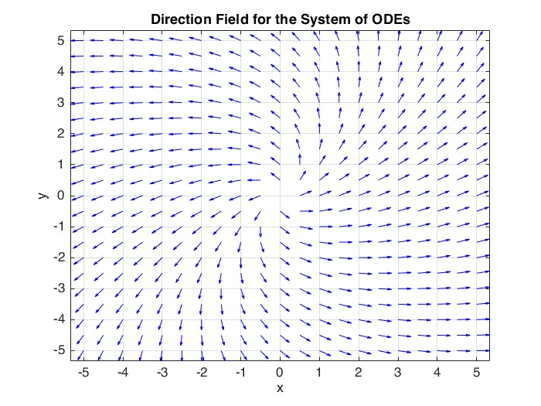

Experiment 2
Aim: Write a program to find the steady state solution draw its phase plane plot for the system of ODE and plot the solution of the system.
Theory: For the system:
$\frac{dx}{dt}$ = ax + by
$\frac{dy}{dt}$= cx + dy
Steady state is obtained by setting:
$\frac{dx}{dt}$ = 0 , $\frac{dy}{dt}$= 0
This gives equilibrium points of the system. Phase plane plots show trajectories around equilibria. Time-domain plots show system evolution.

Code:-
% System coefficients
a = 1;
b = 2;
c = -3;
d = -1;

% Steady-state solution
steady_state = [0 0];
disp('Steady State Solution (x*, y*):');
disp(steady_state);

% Grid for phase plane
[x, y] = meshgrid(-5:0.5:5, -5:0.5:5);

% System equations
dx = a*x + b*y;
dy = c*x + d*y;

% Phase plane plot
figure;
quiver(x, y, dx, dy, 'LineWidth', 1);
hold on;
plot(0, 0, 'ro', 'MarkerSize', 8, 'LineWidth', 2);
xlabel('x');
ylabel('y');
title('Phase Plane Plot of the System');
axis equal;
grid on;
legend('Vector Field', 'Steady State');

% Time span and initial condition
tspan = [0 10];
x0 = [2 -1]; % Initial condition

% Define system for ODE solver
odefun = @(t, x) [
a*x(1) + b*x(2);
c*x(1) + d*x(2)
];

% Solve the system
[t, x] = ode45(odefun, tspan, x0);

% Plot time-domain solutions
figure;
plot(t, x(:,1), 'b', t, x(:,2), 'r', 'LineWidth', 2);
xlabel('Time');
ylabel('State Variables');
title('Solution of the ODE System');
legend('x(t)', 'y(t)');
grid on;

Output:-

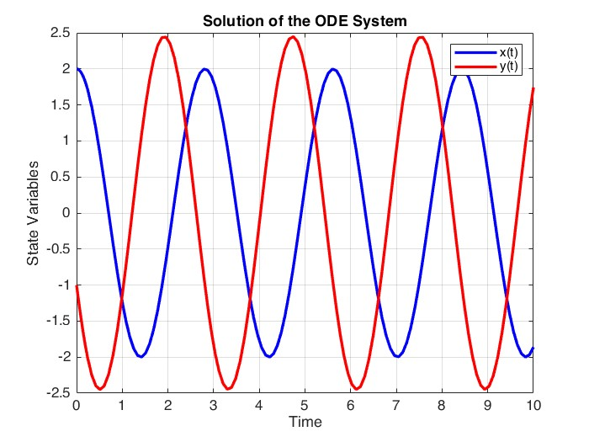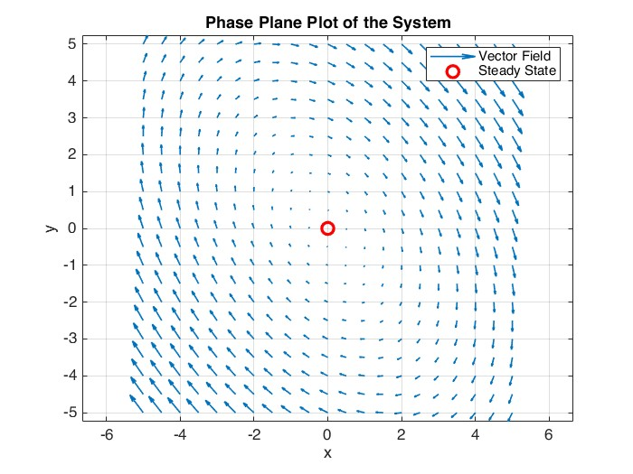
Experiment 3
Aim:- Write a program to find critical points, Jacobian matrix, eigenvalues and eigenvectors of a system of differential equations with constant coefficients.

Theory: Critical points satisfy:

$\frac{dx}{dt}$= 0, $\frac{dy}{dt}$= 0

The Jacobian matrix is:
J =$\left[\begin{matrix}\frac{∂\dot{x}}{∂x} & \frac{∂\dot{x}}{∂y} \\ \frac{∂\dot{y}}{∂x} & \frac{∂\dot{y}}{∂y}\end{matrix}\right]$

Eigenvalues determine stability. Eigenvectors indicate direction of trajectories.

Code
syms x y
f = x + 2*y + 1; % dx/dt
g = 3*x + 4*y; % dy/dt
S = solve([f == 0, g == 0], [x, y]);
critical_point = double([S.x; S.y]);

A = jacobian([f; g], [x, y]);
A = double(A);

[V, D] = eig(A);
EigenValues = diag(D);
EigenVectors = V;

disp('--- RESULTS ---');

disp('Critical Point:');
disp(critical_point);

disp('Jacobian Matrix (Coefficient Matrix):');
disp(A);

disp('Eigenvalues:');
disp(EigenValues);

disp('Eigenvectors (Columns correspond to Eigenvalues):');
disp(EigenVectors);

Output:-

>> Exp3
--- RESULTS ---
Critical Point:
2.0000
-1.5000

Jacobian Matrix (Coefficient Matrix):
1 2
3 4

Eigenvalues:
-0.3723
5.3723

Eigenvectors (Columns correspond to Eigenvalues):
-0.8246 -0.4160

0.5658 -0.9094

Experiment 4
Aim:- Develop a MATLAB function to check the stability of a linear system using the Routh-Hurwitz criteria.

Theory:
The characteristic equation is:

$$a_{n}s^{n}+a_{n-1}s^{n-1}+⋯a_{0}=0$$

Routh-Hurwitz criterion determines stability without solving roots. A Routh array is constructed from coefficients. If all elements of the first column are positive, the system is stable.

Code
coeff = [1, 1, 2, 24];

n = length(coeff);
cols = ceil(n/2);
RouthTable = zeros(n, cols);

% Fill first two rows
RouthTable(1, :) = [coeff(1:2:n), zeros(1, cols - length(coeff(1:2:n)))];
RouthTable(2, :) = [coeff(2:2:n), zeros(1, cols - length(coeff(2:2:n)))];

% Fill remaining rows
for i = 3:n
for j = 1:cols-1
% Calculate determinant for the entry
numerator = RouthTable(i-1, 1) * RouthTable(i-2, j+1) - ...
RouthTable(i-2, 1) * RouthTable(i-1, j+1);

denominator = RouthTable(i-1, 1);

if denominator == 0
denominator = 1e-10; % Avoid division by zero error
end

RouthTable(i, j) = numerator / denominator;
end
end

first_col = RouthTable(:, 1);
sign_changes = 0;
for k = 1:length(first_col)-1
if sign(first_col(k)) ~= sign(first_col(k+1))
sign_changes = sign_changes + 1;
end
end

% 3. DISPLAY RESULTS

fprintf('--------------------------------------------------\n');
fprintf(' Routh Table:\n');
disp(RouthTable);

if sign_changes == 0 && all(first_col ~= 0)
fprintf(' Result: SYSTEM IS STABLE \n');
else
fprintf(' Result: SYSTEM IS UNSTABLE \n');
fprintf(' Sign changes : %d \n', sign_changes);
end
fprintf('--------------------------------------------------\n');

Output:-

>> Exp4
--------------------------------------------------
Routh Table:
1 2
1 24
-22 0
24 0

Result: SYSTEM IS UNSTABLE
Sign changes : 2
--------------------------------------------------
>>

Experiment 5
Aim:- Write a program to check the stability of a linear system using the Lyapunov function.

Theory: A nonlinear system is:
$$\frac{dx}{dt} = f\left(x,y\right)$$

$$\frac{dy}{dt}=g(x,y)$$

Linearization is done near equilibrium points. The Jacobian matrix approximates the system locally. Eigenvalues of the Jacobian determine local stability.

Code:-
% Step 1: Define system matrix A
A = [-2 1; -3 -4];

% Step 2: Choose a positive definite matrix Q
Q = eye(size(A)); % Identity matrix (always positive definite)

% Step 3: Solve Lyapunov equation: A'P + PA = -Q
% Note: lyap(A', Q) correctly solves A'P + P(A')' = -Q -> A'P + PA = -Q
P = lyap(A', Q);

% Step 4: Display P
disp('Matrix P obtained from Lyapunov equation:');
disp(P);

% Step 5: Check if P is positive definite
eigenvalues_P = eig(P);

% Check if eigenvalues are GREATER than 0
if all(eigenvalues_P > 0)
disp('P is positive definite');
disp('System is ASYMPTOTICALLY STABLE (Lyapunov stable)');
else
disp('P is NOT positive definite');
disp('Cannot conclude stability');
end

disp('Eigenvalues of P are:');
disp(eigenvalues_P);

Output:-

>> Exp5
Matrix P obtained from Lyapunov equation:
0.2727 -0.0152
-0.0152 0.1212

P is positive definite
System is ASYMPTOTICALLY STABLE (Lyapunov stable)
Eigenvalues of P are:
0.1197
0.2742
Experiment 6
Aim:- Simulate the Lotka-Volterra prey-predator and analyze the population dynamics over time.

Theory:
The Lotka-Volterra prey-predator model is described by the system of nonlinear differential equations:
$$\frac{dx}{dt} = ax - bxy$$$$\frac{dy}{dt} = cxy - dy$$

where:
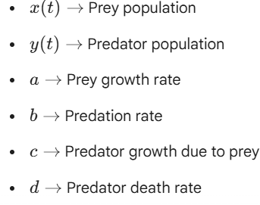
The term a$x$ represents the natural growth of the prey population, while the term bxy represents the reduction in prey due to predation. The term cxy represents the increase in predator population due to prey availability, while the term dy represents the natural decay of the predator population. The system exhibits oscillatory behavior around an equilibrium point, representing cyclic population dynamics.

Hopf bifurcation occurs when eigenvalues cross the imaginary axis:

$$λ= α(r)±jω$$
As parameter r varies, equilibrium loses stability. A limit cycle is created. The system exhibits oscillatory behavior.

Code
a =1.1;
b=0.4;
c=0.1;
d=0.4;
params = [a;b;c;d];

y0 = [10; 5];

tspan = 0:0.1:50;
[t, y] = ode45 (@(t,y) LVeqn(t,y,params), tspan, y0);
figure;
plot(t, y(:,1), 'LineWidth', 1);
hold on;
plot(t, y(:,2), 'LineWidth', 1);
hold off;
legend ('Prey', 'Predator');
set (gca, 'LineWidth', 1, 'FontSize', 10);
title('Prey-Predator Model');
xlabel ('Time');
ylabel('Population');
figure;
plot (y(:,1), y(:,2), 'LineWidth', 1);
xlabel('Prey');
ylabel('Predator');
title('Prey vs Predator');
set (gca, 'LineWidth', 1, 'FontSize', 10);
u = 0:1:20;
v = 0:1:10;
[u,v] = meshgrid (u,v);

V1 = a*u-b*u.*v;
V2 = c*u.*v-d*v;
VF = sqrt (V1.^2 + V2.^2);
hold on;
quiver (u, v, V1./VF, V2./VF, 0.5);
axis([0 20 0 10]);
hold off;
function df = LVeqn(~, var, params)
a = params(1);
b = params(2);
c = params(3);
d = params(4);
x = var(1);
y = var(2);

df = zeros(2,1);
df(1) = a*x - b*x*y;
df(2) = c*x*y - d*y;
end

Output:-

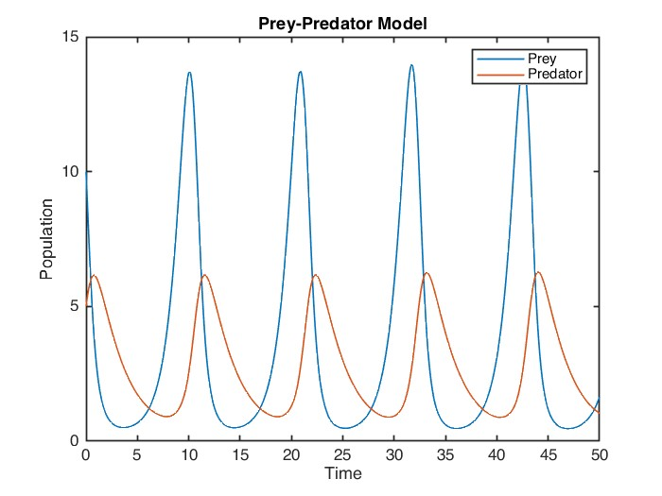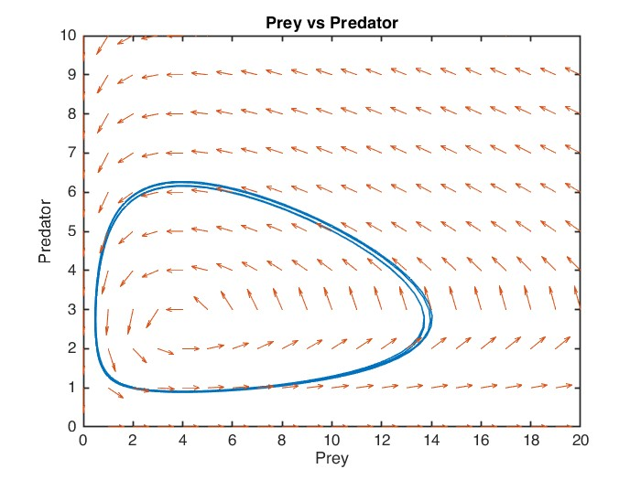
Experiment 7
Aim:- Implement the SIR model for an epidemic and analyze how varying parameters (infection rate , recovery rate) affect the spread of disease.

Theory: The SIR model is

$\frac{dS}{dt}$ = −𝛽𝑆𝐼

$\frac{dI}{dt}$= 𝛽𝑆𝐼− 𝛾𝐼

$\frac{dR}{dt}$ = 𝛾𝐼
Here, 𝛽 is infection rate and 𝛾 is recovery rate. The model explains diseases spread dynamics.

Code:-

beta = 0.3;

gamma = 0.1;

S0 = 0.99;

I0 = 0.01;

R0 = 0;

x0 = [S0 I0 R0];

tspan = [0 160];

sir = @(t,x)[

-beta*x(1)*x(2);

beta*x(1)*x(2)-gamma*x(2);

gamma*x(2)

];

[t,x] = ode45(sir, tspan ,x0);

figure;

plot(t,x(:,1),'b',t,x(:,2),'r',t,x(:,3),'g','LineWidth',2);

xlabel('Time');

ylabel('Population Fraction');

title('SIR Model Simulation');

legend ('Susceptible', 'Infected', 'Recovered');

grid on;

beta_values = [0.2 0.4 0.6];

gamma = 0.1;

figure;

hold on;

for beta = beta_values

sir = @(t, x)[

-beta*x(1)*x(2);

beta*x(1)*x(2) - gamma*x(2);

gamma*x(2)];

[t, x] = ode45 (sir, tspan, x0);

plot(t, x(:,2), 'LineWidth', 2);

end

xlabel('Time');

ylabel('Infected Population');

title('Effect of Infection Rate (\beta)');

legend('\beta = 0.2', '\beta = 0.4', '\beta = 0.6');

grid on;

beta = 0.4;

gamma_values = [0.05 0.1 0.2];

figure;

hold on;

for gamma = gamma_values

sir = @(t, x) [ -beta*x(1)*x(2);

beta*x(1)*x(2) - gamma*x(2);

gamma*x(2)

];

[t, x] = ode45 (sir, tspan, x0);

plot(t, x(:,2), 'LineWidth', 2);

end

xlabel('Time');

ylabel('Infected Population');

title('Effect of Recovery Rate (\gamma)');

legend ('\gamma = 0.05', '\gamma = 0.1', '\gamma 0.2');

grid on;

Output:-
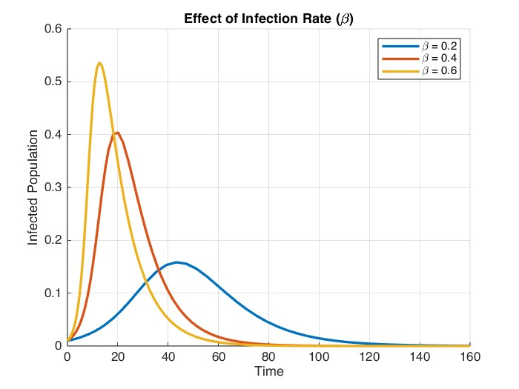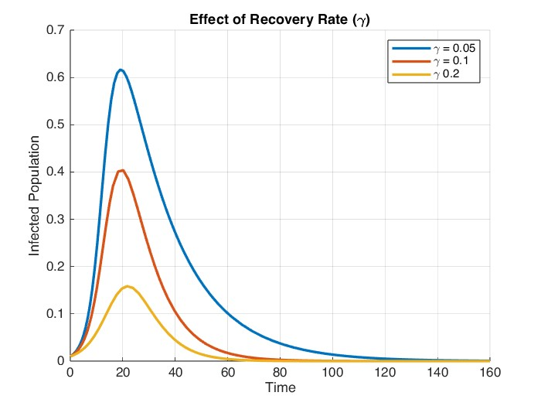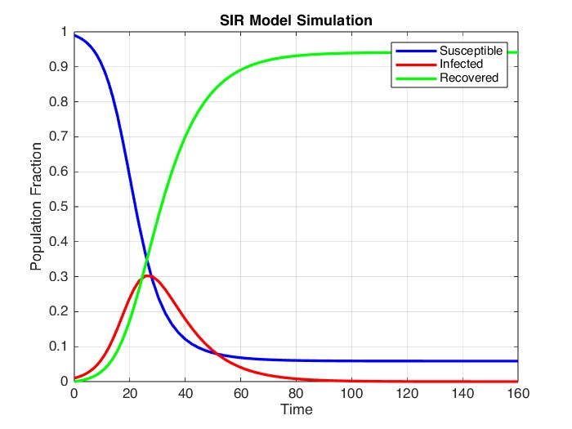
Experiment 8
Aim: Simulate and analyze the saddle node bifurcation in a simple dynamical system.

Theory:
A standard system showing saddle node bifurcation is

$$\frac{dx}{dt}=r-x^{2}$$
r is the bifurcation parameter
for r < 0: No equilibrium points =𝑟−𝑥2
for r > 0: Two equilibria (one stable and one unstable)
for r = 0: One equilibrium (Bifurcation point)

Code
r = linspace(-2 ,2 ,400);
x1 = sqrt(r);
x2 = -sqrt(r);
x1(imag(x1) ~= 0) = NaN;
x2(imag(x2) ~= 0) = NaN;
figure;
plot(r,x1,'b','LineWidth',2);
hold on;
plot(r,x2,'r--','LineWidth',2);
plot(0,0,'ko','MarkerSize',8,'LineWidth',2);
xlabel('Bifurcation Parameter r');
ylabel('Equilibrium points x');
title('Saddle-node Bifurcation Diagram');
legend('Stable Equilibrium ','Unstable Equilibrium','Bifurcation point');
grid on;
tspan = [0 10];
x0 = 0.5;
r_values = [-1, 0, 1];
figure ;
hold on;
for r = r_values
f = @(t,x) r-x.^2;

[t,x] = ode45(f, tspan,x0);
plot(t,x,'LineWidth',2);
end
xlabel('Time');
ylabel('State x(t)');
title('Time response for different r values');
legend('r=-1','r=0','r=1');
grid on;

Output
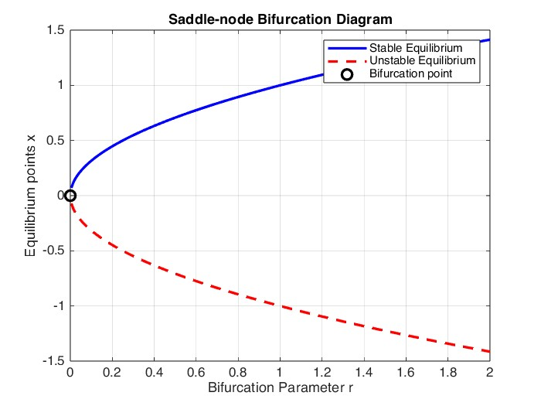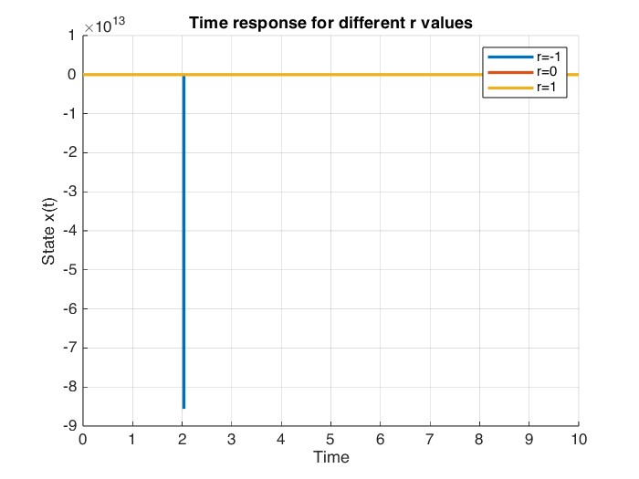
Experiment 9
Aim: Simulate a transcritical bifurcation in a simple system.

Theory:
A standard system showing transcritical bifurcation is
$$\frac{dx}{dt}=rx-x^{2}$$
r is the bifurcation parameter.
Equilibrium points are: x = 0, x = r
At r = 0, stability of equilibria is exchanged.

Code
% --- Transcritical Bifurcation Diagram ---
r = linspace(-2, 2, 400);
x1 = zeros(size(r));
x2 = r;

figure;
plot(r, x1, 'r--', 'LineWidth', 2);
hold on;
plot(r, x2, 'b', 'LineWidth', 2);

% The stray line "=𝑟𝑥− 𝑥2" was removed from here.
% The system equation is dx/dt = r*x - x^2

plot(0, 0, 'ko', 'MarkerSize', 8, 'LineWidth', 2);
xlabel('Bifurcation parameter r');
ylabel('Equilibrium Points x');
title('Transcritical Bifurcation Diagram');
legend('x = 0 (Unstable to Stable)', 'x = r (Stable to Unstable)', 'Bifurcation Point');
grid on;

% --- Time Response Simulation ---
tspan = [0 10];
x0 = 0.5;
r_values = [-1, 0, 1]; % Changed 0.5 to 0 so it matches your legend

figure;
hold on;
for r = r_values
f = @(t,x) r*x - x.^2;
[t,x] = ode45(f, tspan, x0);
plot(t, x, 'LineWidth', 2);
end

xlabel('Time');
ylabel('State x(t)');
title('Time Response Showing Transcritical Bifurcation');
legend('r = -1', 'r = 0', 'r = 1');
grid on;

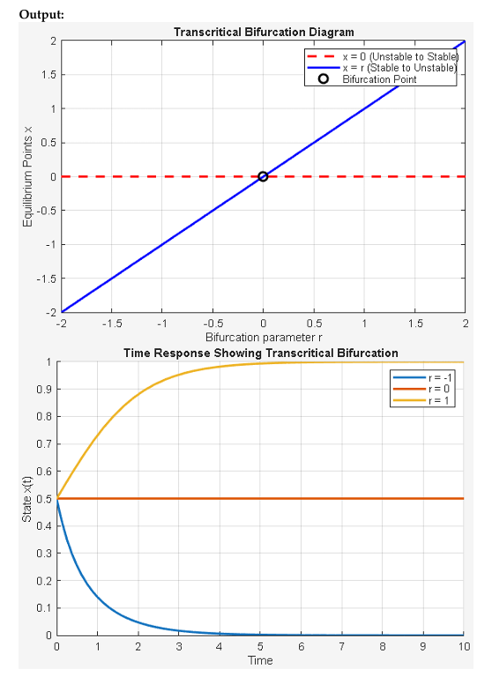

Experiment 10
Aim: Simalate the chantic behaviour of the Lorenz system.

Theory:
The Lonme-system is
$\frac{dx}{dt}$= $σ$(y-x)
$\frac{dy}{dt}$ = x(p-z)-y
$\frac{dz}{dt}$= xy-$β$z
The system exhibits chaos for specific paranieter values. It shows sensitivity to initial conditions. Phase plots reveal strange attractors

Code:-

% Lorenz system parameters

sigma = 10;

rho = 28;

beta = 8/3;

% Time span and initial condition

tspan = [0 50];

x0 = [1 1 1];

% Lorenz equations

lorenz = @(t, x) [

sigma*(x(2) - x(1));

x(1)*(rho - x(3)) - x(2);

x(1)*x(2) - beta*x(3)

];

% Solve ODE

[t, x] = ode45(lorenz, tspan, x0);

% Plot time response

figure;

plot(t, x(:,1), t, x(:,2), t, x(:,3), 'LineWidth', 1.5);

xlabel('Time');

ylabel('States');

title('Time Response of Lorenz System');

legend('x(t)', 'y(t)', 'z(t)');

grid on;

% 3D Phase space plot

figure;

plot3(x(:,1), x(:,2), x(:,3), 'k', 'LineWidth', 1);

xlabel('x');

ylabel('y');

zlabel('z');

title('Lorenz Chaotic Attractor');

grid on;

Output:-

